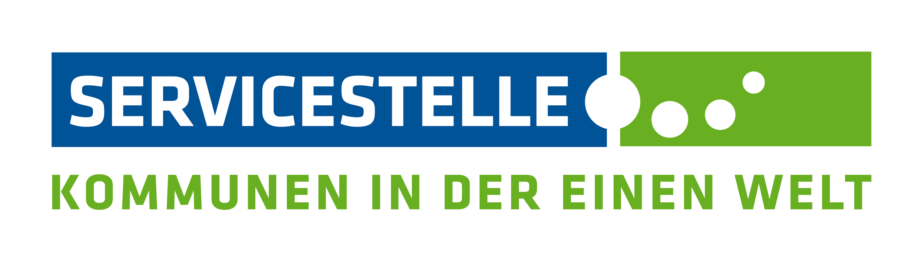

Please submit by:
23 November 2023

Travel expenses claim form

To:
Engagement Global gGmbH
Service Agency Communities in One World
c/o Tobias Retzbach
Friedrich-Ebert-Allee 40
53113 Bonn
Germany

I hereby request reimbursement of the following costs:

Details of the trip
1.
Reason for the trip:
Dates: | from: |  |  | to:
Destination/venue: | town/city: |  |  | country:
Point of departure¹⁾: | private address: |  | ☐ | work address: |  | ☐
Point of arrival¹⁾: | private address: |  | ☐ | work address: |  | ☐
¹⁾ Please tick the appropriate boxes
2.
Private address: | last name: |  | first name:
 | street |  | house no.:
 | postcode: |  | city or town:

Work address: | name of institution:
 | street |  |  | house no.:
 | postcode: |  |  | city or town:
3.
Explanation of why the point of departure/arrival differs from the address given
Different address | street |  | house no.:
 | postcode: |  | city or town:

Other trip participants for whom you are also claiming expenses
4.
Last name, first name / address:
Last name, first name / address:
Last name, first name / address:
Last name, first name / address:
Last name, first name / address:

Bank details
5.
Account details²⁾ | ☐ private account ☐ business account
Name of bank:
BIC:
IBAN (German)³⁾:
IBAN (foreign)⁴⁾:
Purpose text:
²⁾ Please tick the appropriate box
³⁾ Please enter IBAN for German accounts (22 digits)
⁴⁾ Please enter IBAN for foreign accounts

Please submit original vouchers for the costs
6.

Travel expenses (Please number vouchers):
8.
7.
Type of expenditure | Voucher number | Amount in foreign currency⁵⁾ | Amount in EUR | Corrections  by the Service Agency
Rail, 2nd class (total costs)
Seat reservation (total costs)
Flight ticket, economy class (total costs)⁶⁾
Bus, tram, underground etc.
Other
Taxi (only if explained)
Parking fees
(max. €15.- per day)
Travel in your own car (€0.20/km, max. €130.-;only full kilometres, figures must be rounded down) | Outward and return journey:  km  (max.  650 km)
Point of departure:

Point of arrival:

Sum total for travel expenses:
⁵⁾ Only enter foreign currency for trips outside Germany
⁶⁾ Flights within Germany will not be reimbursed

Overnight accommodation expenses (Please number vouchers):
9.
11.
Type of expenditure: | Voucher number | Amount in foreign currency | Amount in EUR | Corrections  by the Service Agency
Name of hotel, city/town, country:

Overnight accommodation
(dates from - to):
Number of nights stayed:
Costs:
Name of hotel, city/town, country:

Overnight accommodation
(dates from - to):
Number of nights stayed:
Costs:
Name of hotel, city/town, country:

Overnight stay
(dates from - to):
Number of nights stayed:
Costs:
Subtotal for overnight accommodation expenses:
Daily allowance
(to be filled in by the Service Agency)
Sum total for overnight accommodation expenses
(to be completed by the Service Agency)
10.

Vaccination costs / visa costs (Please number vouchers): ONLY for MISSIONS
11.
Type of expenditure: | Voucher number | Amount in foreign currency | Amount in EUR | Corrections  by the Service Agency
Sum total for vaccination costs

Grand total for all expenses incurred
Total to be reimbursed
(to be completed by the Service Agency)

12.
I declare that I will not request or claim any reimbursement of travel expenses from any other source.

Place | Date | Signature

Explanatory notes on the travel expenses form

- Please indicate the reason for, date and place of the event / trip.

- For calculation purposes, please enter your private and work addresses.

- Point of departure/arrival differs from the address given: If the point of departure or arrival differs from the addresses given under 2, this needs to be explained, and a comparative offer submitted for the actual day of travel. In this case, costs are only eligible up to the amount for the normal route (from your private address or work address to the venue/destination).

- If advance payment has been made for other participants, these costs can also be settled using the travel expenses form. If money is to be transferred to the claimant's private account, then the consent of the named participants is required. They can give their written consent either by signing field 4 or by supplying a separate document.

- Checkboxes: Here you need to tick either 'private account' or 'business account'. You may only select one option.
IBAN: Please fill in the bank details in full. A German IBAN always has 22 digits. In order to avoid incorrect transfers, please check the account details once again after filling in the fields.

- Costs can only be reimbursed if the original vouchers are provided. To speed up processing, please note the following: Please do not staple loose receipts together. Instead, stick them on a DINA4 sheet, number them consecutively and submit them.

- Please number all vouchers consecutively. This makes it easier for us to assign and thus process them much more quickly.
Taxi: Taxi costs can only be reimbursed if there is a valid reason according to Section 4 para. 4 of the German Federal Travel Expenses Act (BRKG). In this case, please also submit a written note explaining why it was necessary to use a taxi. Parking fees: A maximum of €15.- per day can be reimbursed against proof.

- Travel costs by car: A maximum of €130.- or 650 km x €0.20 can be reimbursed for the outward and return journey. A route printout (e.g. Google Maps) is always required for this. Participants may only claim a lump sum per kilometre when using their own car. If this is not the case, please contact the Service Agency in advance.

- Due to the rules on overnight accommodation allowances abroad (ARVVwV), please discuss and agree on hotel bookings with the Service Agency.

- Daily allowances will be calculated by the Service Agency. Please also sign and submit the document on meals received.

- Vaccinations will be reimbursed if they are mandatory (compulsory vaccinations). Vaccinations recommended by the German Federal Foreign Office also qualify as mandatory. Vaccinations against diseases in infectious or endemic regions that are officially recommended can also be reimbursed. The official recommendation must be certified by the medical service of your organisation/institution. The costs incurred can only be reimbursed against proof.

- Please enter the place, date and your signature on the form when claiming the reimbursement of travel expenses. Forms that are not signed cannot be processed.

